CENTRAL INDIA EXPORT

IRISH CLAW (Lens Design):

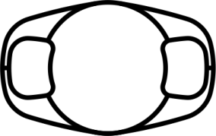

Brand Name | IO VUE
Lens Type | PMMA Single Piece Posterior Chamber Intraocular Lens.
Material | PMMA-CQ-with UV Blocker
Model | WIC5580PC
Optic Diameter | 5.50mm
Overall Diameter | 8.00mm
Haptic Design | Irish claw
Optic Design | Spherical Biconvex
Estimated A.Constant | 115.4
Available Powers | 0.00 D to 6.00 in 1.0D steps.  6.00 to 30.00D in 0.5 D steps.

Another model ::5.00mm/8.5mm also available

